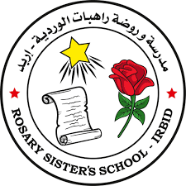
Rosary Sisters School
KG 1 Newsletter
From 1/10 to 31/10
Opposites:
Big - small
Fast - slow
left - right
Up - down
Tall - short
Go - stop

Language scheme:
Dd, Ee, Ff, Gg

Objectives: learn the letters:
-Write the letter correctly (Capital and small).
-Name three words for each letter
-Work with the exercises book
-Practice the action sound of each letter.

Jolly Phonics:
Dd: Dress, door, dog. Ff: Frog, flower, fish.
Ee: Elephant, egg, elbow. Gg: Green, goat, girl.

Sight words:
I, to, we, on
she, can
Math:
Numbers: 1,2,3,4 and 5
Shapes: circle, square and triangle.
Colors: red, yellow, green, and blue.

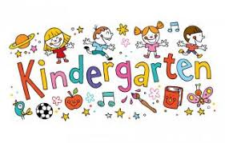
Teachers: Diana Guvlekjian and Nisreen Haddad.
Science:
Five senses

