
Rosary School / Irbid
(4^{th)} grade
English Study sheet (9)
Name: ____________________ Date: / 11 / 2025

*Comparative and superlative adjectives, as…..as:
*We use the comparative to talk about how two things compare.
*To form comparative adjectives, add (er to the adjective) + than.
*Rule: Subject + verb to be (am, is, are) + comparative adjective + than + complete the sentence.
*Examples:
-Mrs. Friendly is taller than Su-Lin.
-Ahmad is stronger than Sami.
-My apple is bigger than yours.
-He runs faster than Ahmad

-We use the superlative to say something has more than the rest of the group.
-To form the superlative adjectives, we add
(the + (adjective+est) ).
*Rule: Subject + verb to be (is , are, am) + the + (adjective +est) + complete the sentence.
*Examples:
-Ivan is the tallest person in Diversicus.
-Sarah is the prettiest girl at school.
-Mount Everest is the highest mountain in the world.
-My mom is the best cook ever.

*We use as…..as to say that two things are the same.
*Rule: Subject + verb to be (is, are, am) + as + adjective + as + complete the sentence.
*Don’t add anything to the adjective when forming (as….as) sentences.
*Examples:
-Ivan is as tall as a tree.
-Jude runs as fast as James.
-My car is as expensive as yours.
-Noor is as smart as Tala.
-My garden is as colorful as your garden.

Rosary School / Irbid
(4^{th)} grade
English Study sheet (9)
Name: ____________________ Date: / 11 / 2025

*Remember:
-We use -er/ est with short adjectives like
small= smaller/smallest.
-We use more/the most with long adjectives like dangerous= more/ the most dangerous.

*These are irregular adjectives, memorize them.
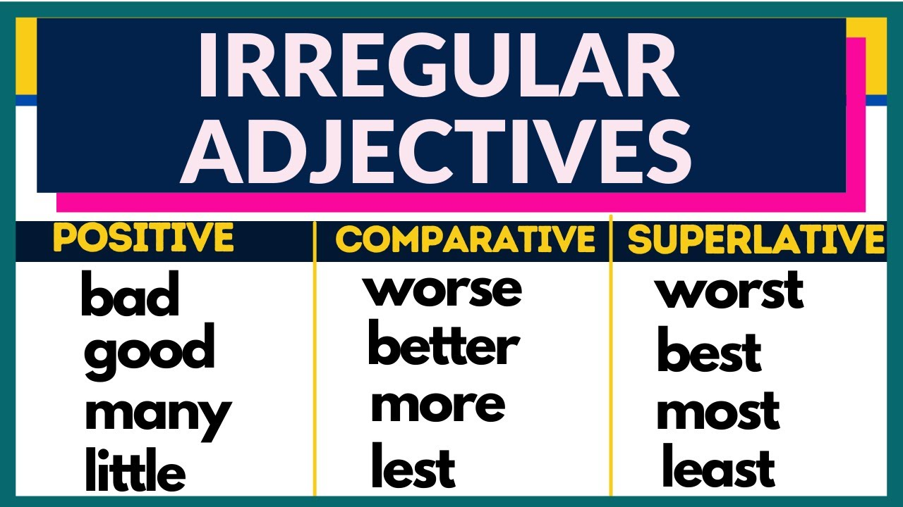
T. Yasmeen Okour

