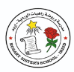
Rosary School / Irbid
Grade (4)
English Study sheet (10)
Name: ____________________ Date: / / 2025

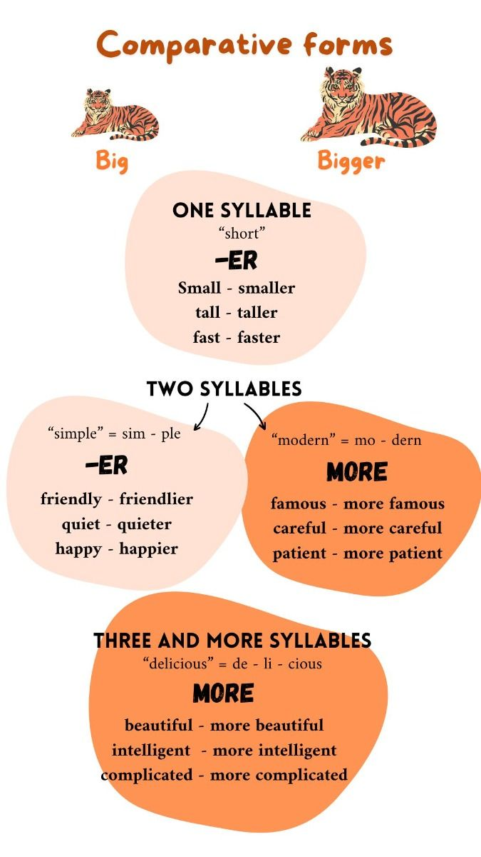

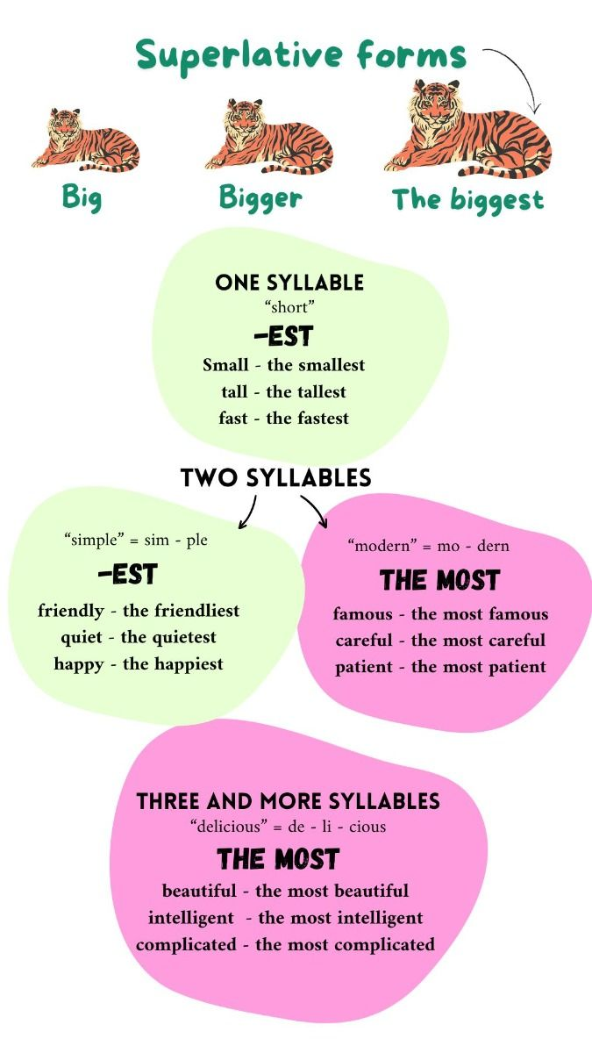

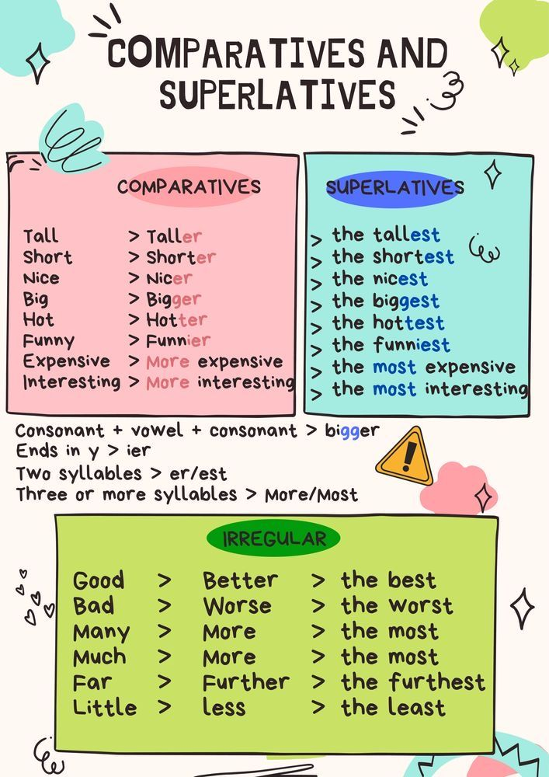

T. Yasmeen Okour

