
Rosary School / Irbid
Grade (4)
Worksheet (15)
Name: ____________________ Date: / / 2025

Q1: Choose the correct comparative form of the adjectives.
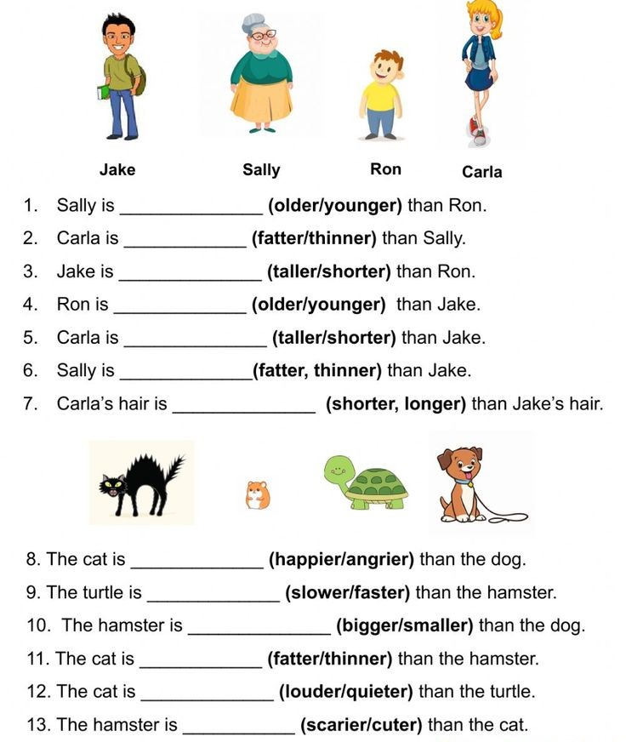

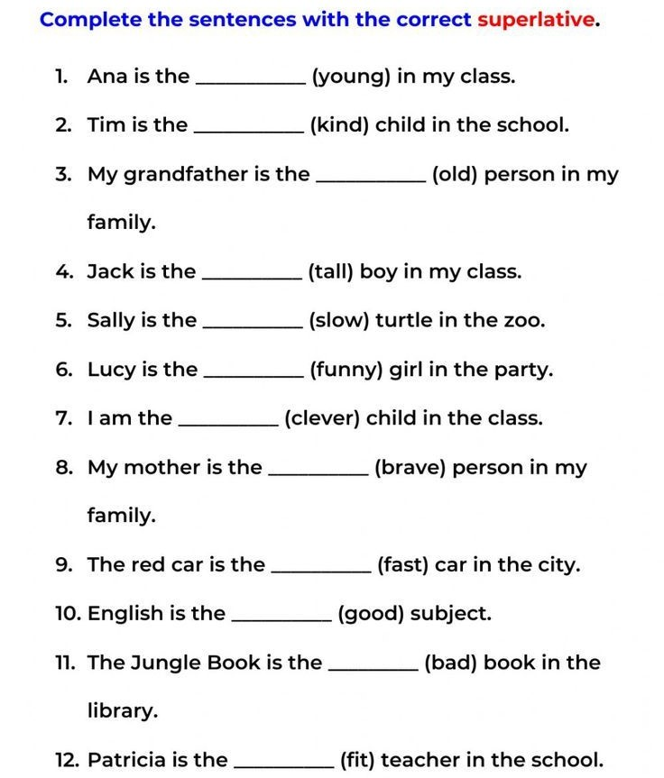

Rosary School / Irbid
Grade (4)
Worksheet (15)
Name: ____________________ Date: / / 2025

#Remeber when we form the comparative (not as, as) the adjective stays the same.
#Example: Mrs. Friendly and Su-lin aren’t as tall as Ivan.

Q3: Complete the sentences with the correct (verb to be) and the comparative form (as + adjective + as).
1.The man __________________________(is/not) (tall) the tree.
2.Lara and Sarah _____________________________ (are/not) (fat) Maya.
3.Mr. Miguel _________________________ (is/not) (strong) Ivan.
4.John __________________________ (is/not) (clever) Nour.
5.Lara and Maya __________________________ (are/not) (fast) Sarah.

T. Yasmeen Okour

