Name: ___________ Date: __/__/2025
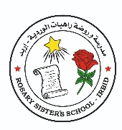
Rosary Sisters School
Study Sheet - Grade 5

The Lion of The Seas
- Occupation: job / skill
- An inventor: creator / maker
- Around 1430: about 1430
- Julfar = Ras Al Khaimah: one of the emirates in the United Arab Emirates
- Navigation: finding the way
- Confident: a state of self-belief / bold
- position: place / location
- The tides: the rising and falling of the sea
- Roughest: hardest
- Distant: far
- Interest: hobby
- Sea routes: waterways / any path or track used for navigation
- Principles: rules
- An encyclopedia: is a reference that gives you information about all kinds of topics
- The astrolabe: is a device used to measure the position of the stars and used on ships to calculate the ship’s position. (The compass and the astrolabe helped the sailors find where they were.)
- Instruments: tools such as the compass and the astrolabe
Tr. Hazar Tashman

