
Rosary Sisters School – Irbid
Study Sheet (The Ordinal Numbers)
Grade 5 ( a, b, c )
Student’s name: _____________ Date: ___/___/2025

- An Ordinal number is the number that indicates the position of something or someone at a place.
- A Cardinal Number is a number that says how many of something there are, such as one, two, three, four, five. (counting number)
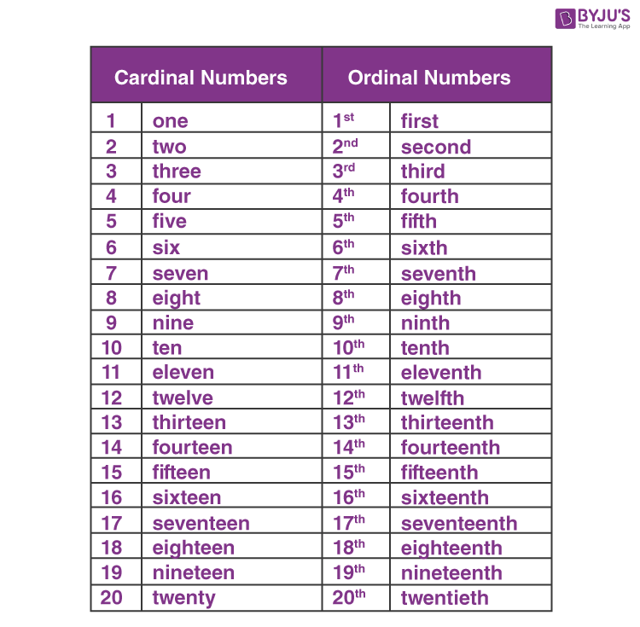

- Write the ordinal number next to each sentence.
- Rami came first in class.
- Lara was the third girl standing in a row.
- Mohammed stays on the fourth floor of the apartment.
- The table is kept at the sixteenth position in the display of the shop.

- Practice Questions on Ordinal Numbers.
- What is the fifth letter in the word “BEAUTIFUL”?
- In the word “MADAM”, find the first and last letters?
- “There are ten ducks in a lake”. Find the 9th letter in the given sentence.
- In the word, “MAGNIFICENT”, letter (I) is the _________ and the _____________.
- What is the ordinal number of 37?
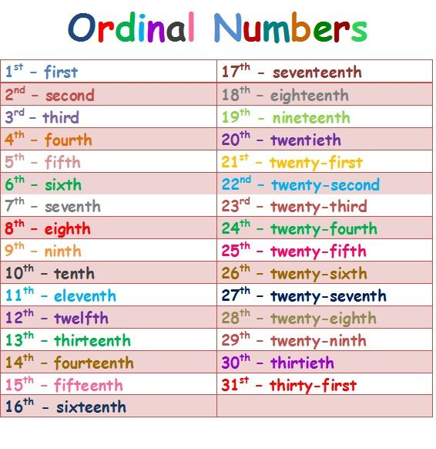

Mrs. Hazar Tashman

