
Rosary Sisters School – Irbid
The Indefinite Pronouns
Study Sheet
Name: …………………. Date: …../…../2025

- An indefinite pronoun does not refer to any specific person, thing or place.
- every = all 3. some = one
- any = with questions 4. no- = none

Examples:
- Somebody/someone wants to speak to you.
- There is something happening outside.
- Nobody/no one is at their best when they’ve just woken up.
- Is anyone still outside?
- It was a very clear day. We could see everything.
- Let’s pretend we are going on an adventure somewhere far away.
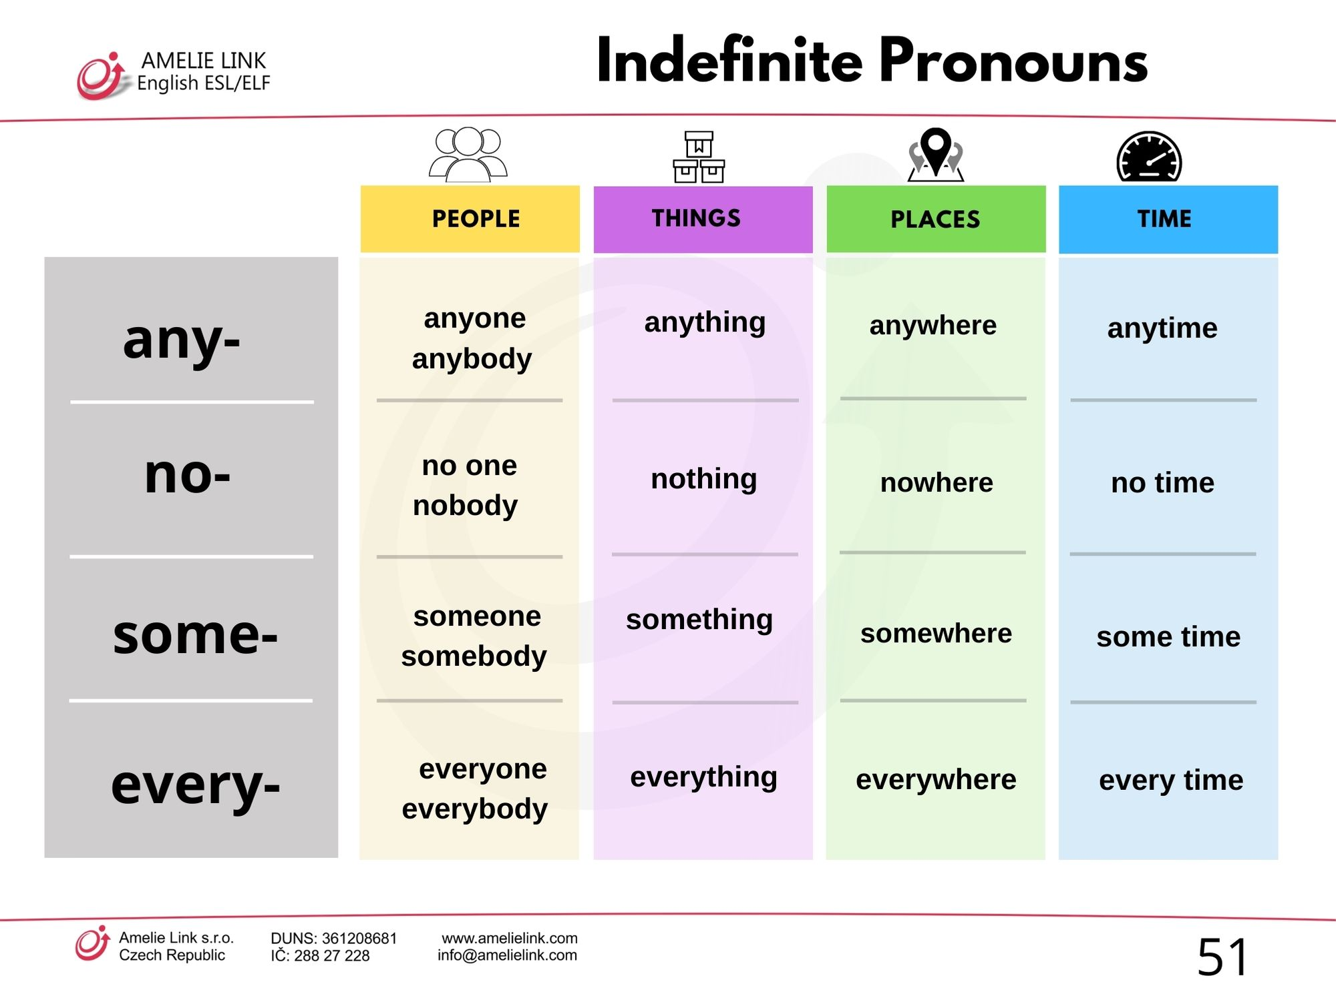

Name: _________________

Part A
Q1. Underline the indefinite pronouns in these sentences:
- Someone is knocking at the door.
- Everyone was excited for the school trip.
- His song is waited by fans everywhere.
- No-one wanted to be late.
- He needs somewhere to live in Cairo.
- Do you need anything at the store?

Part B

Q2. Complete the following sentences using one of the indefinite pronouns.

- Does ______________ have a phone charger?
- She wants to live ______________ by the sea. ( a certain place)
- She didn’t bring ________________ to the party.
- I wish ___________ would clean this mess up!
- Check that bag! I bought _____________ for you.
- I looked _______________ for my cat, but I couldn’t find it.
- ________________ came to school because it was a holiday.
- _________________ was on time. No one was late.
- I didn’t go ___________ on the weekend, so I am really bored.
- The doctor did _____________ to save her.


Part C
Challenge: Write a short paragraph (4-5) sentences about your school day using at least 3 indefinite pronouns.
_____________________________________________________________________________________________________________________________________________________________________________________________________________________________________________________________________________________________

Mrs. Hazar Tashman

