4th grade spelling words list
jiggle | pleasant | practical | enclosure | crop | bridge
brake | monitor | illusive | engine | chose | acknowledge
shake | brought | courage | pressure | forgot | happier
problem | swam | fatal | history | handout | physician
school | celebrate | reached | geology | butcher | aggressive
near | drove | local | village | establish | politician
paddle | scratch | celery | cherry | although | exhibition
again | enemy | cure | treasure | borrow | president
bake | hours | bought | strange | dough | behavior
gentle | write | wife | hairstyle | account | preach
metal | heard | division | century | swimmer | reschedule

Rosary School / Irbid
Spelling
(4^{th)} grade
Name: ____________________ Date: 20/ 11 / 2025
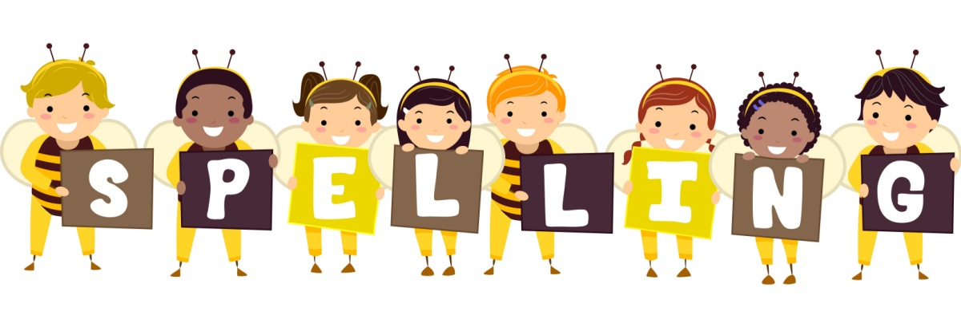

Dear Parents:
We will have a spelling competition out of 20 marks as a third assessment, help your child spell them correctly, here are the words. The competition will be held in November.

