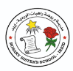
Rosary School / Irbid
(4^{th)} grade
English extra worksheet
Name: ____________________ Date: 19 / 11 / 2025

#Homework: Write a comic story from (4-6) pictures about one of these topics. It will be marked for the speaking, and writing third test on 19th / November.
1.How to save the environment.
2.How to be kind.
#Look at these examples but don’t use them.
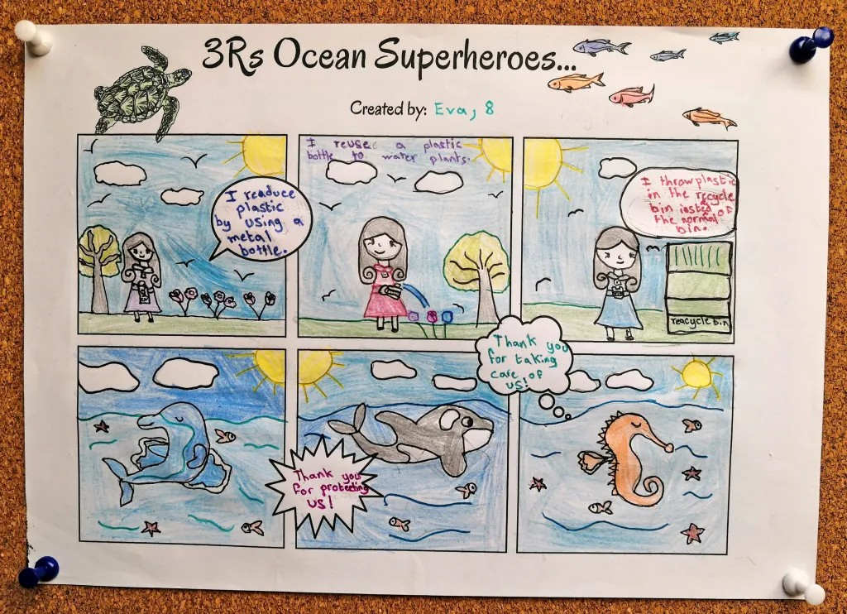

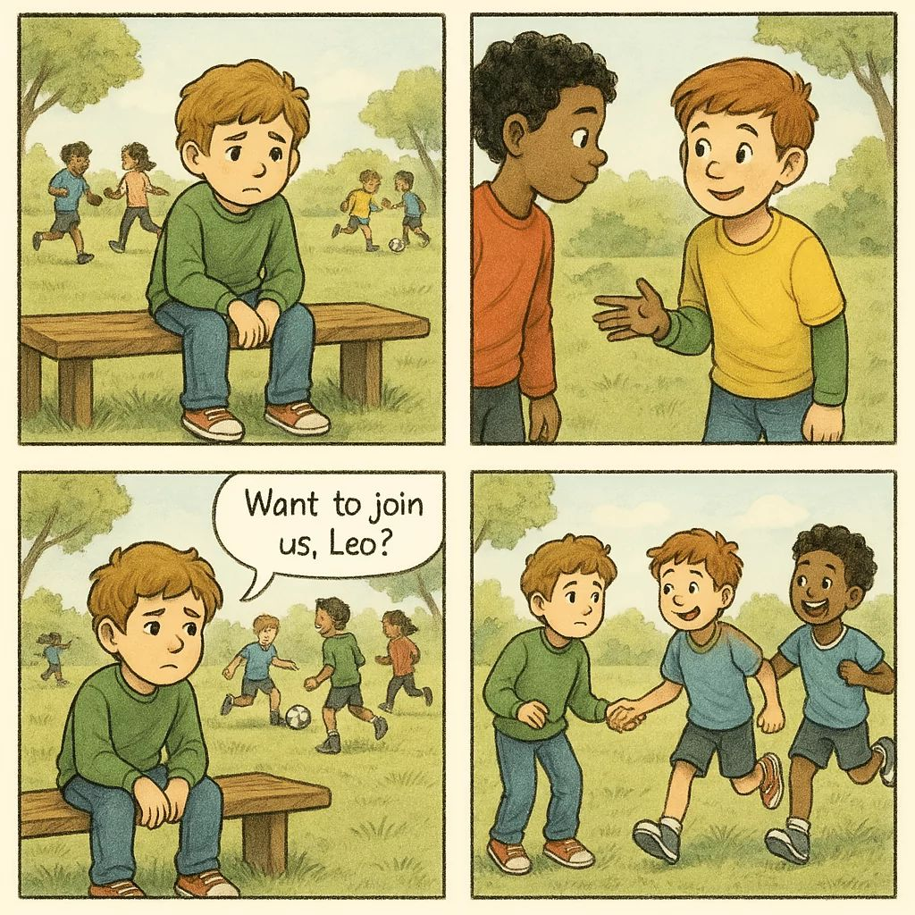

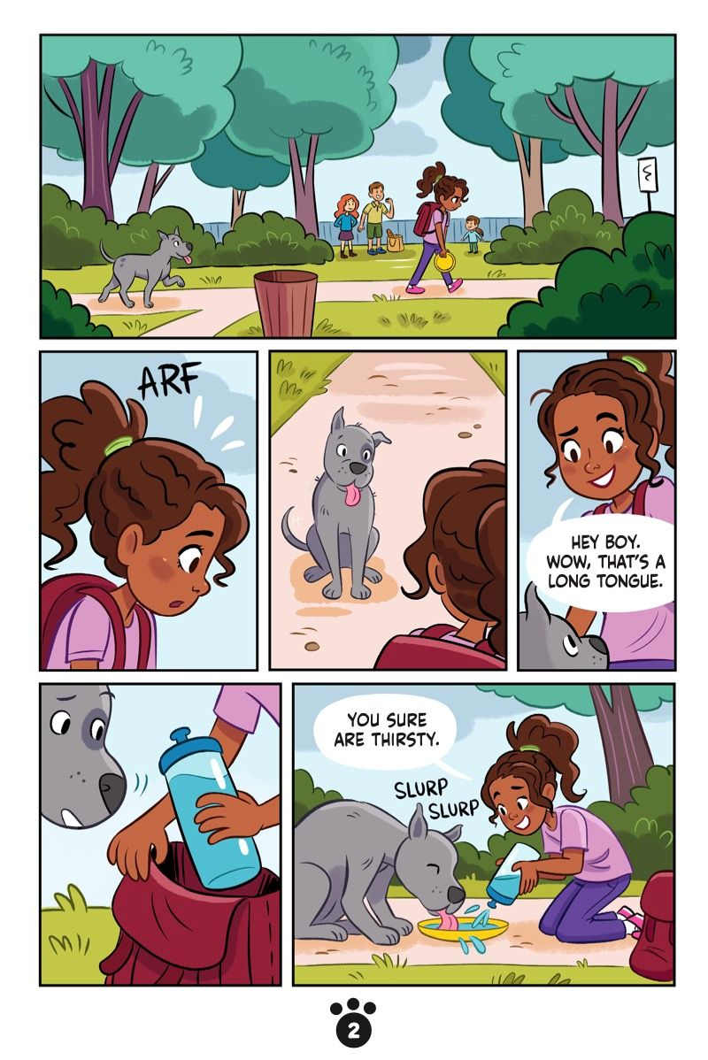
19

