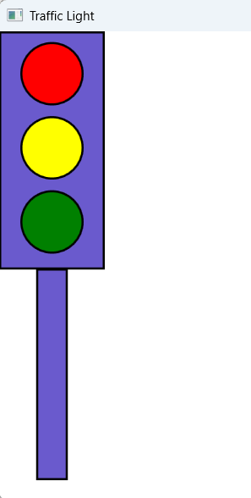
GraphicsWindow.Title="Traffic Light"

Shapes.AddRectangle(100,225)
B= Shapes.AddRectangle(30,200)
Shapes.Move(B,35,224)

GraphicsWindow.BrushColor="Red"
R= Shapes.AddEllipse(60,60)
Shapes.Move(R,20,10)

GraphicsWindow.BrushColor="Yellow"
Y= Shapes.AddEllipse(60,60)
Shapes.Move(Y,20,80)

GraphicsWindow.BrushColor="Green"
G= Shapes.AddEllipse(60,60)
Shapes.Move(G,20,150)

