
Rosary school / Irbid
Study sheet grade 8 unit 3
The adjective of feeling
Adjective of feelings:

Positive Feelings
Adjective | Meaning
Happy | feeling good
Excited | full of energy
Calm | relaxed
Proud | pleased with yourself
Confident | sure of yourself
Hopeful | expecting good things
Grateful | thankful
Cheerful | joyful
Interested | wanting to know more
Relaxed | not stressed


Negative Feelings
Adjective | Meaning
Sad | unhappy
Angry | mad
Worried | thinking something bad might happen
Nervous | shaky or unsure
Tired | needing rest
Frustrated | annoyed because something is hard
Afraid | scared
Bored | not interested
Lonely | feeling alone
Confused | not understanding

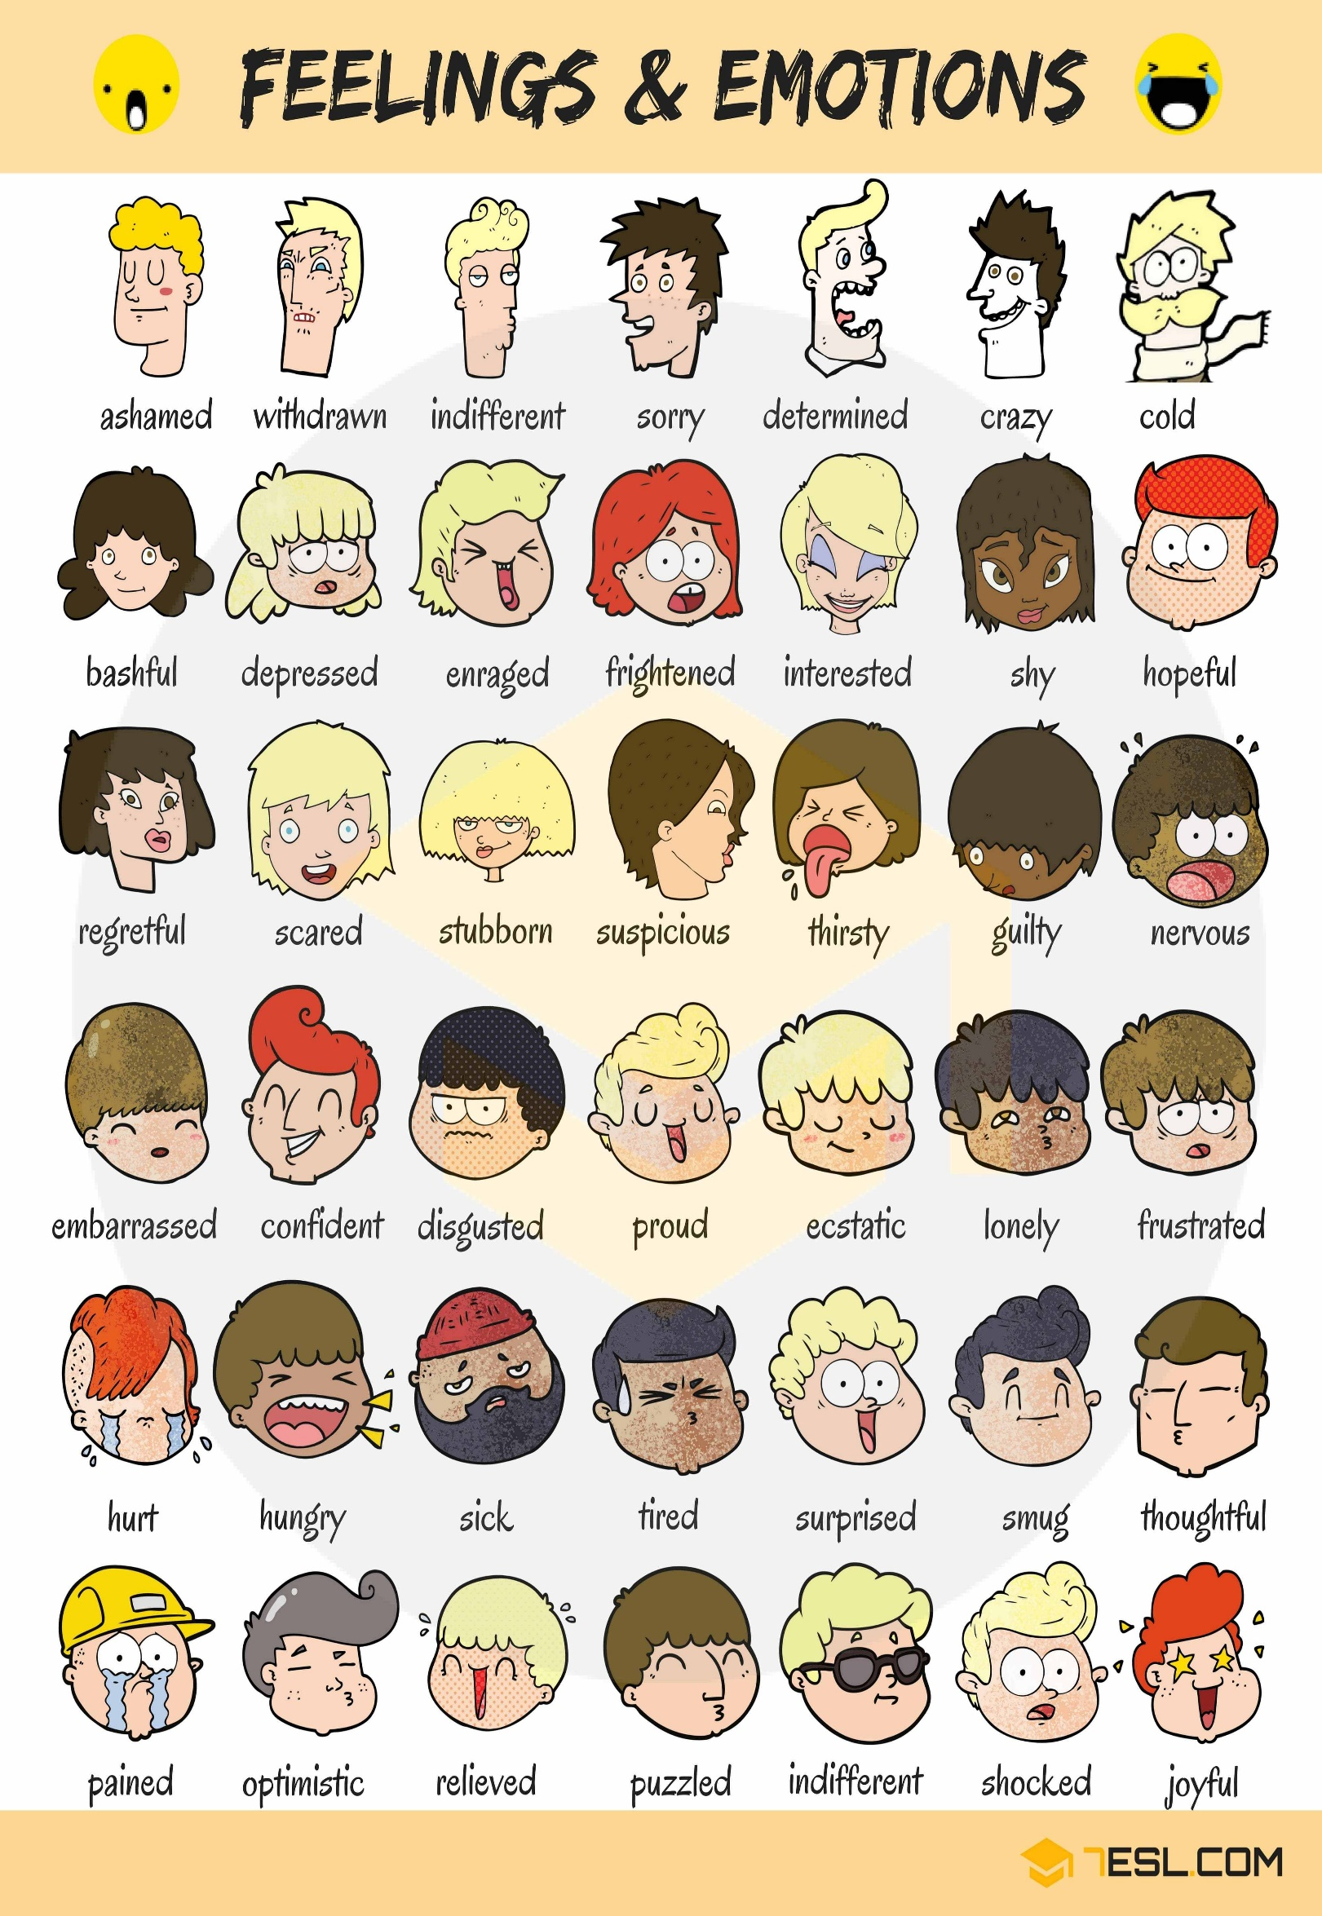

Study Sheet: Past Simple & Past Continuous

1. Past Simple
We use the past simple to talk about:
- Finished actions in the past.
- Actions that happened once, twice, or many times.
- A sequence of actions

Form

A. Regular Verbs:
Add -ed to the verb.
- play → played
- watch → watched
- walk → walked

B. Irregular Verbs (must memorize):
- go → went
- see → saw
- eat → ate
- have → had
- come → came

Negative Form:
did not + base verb
- I did not go to school.
- She did not watch TV.

Question Form:
Did + subject + base verb?
- Did you eat breakfast?
- Did they come early?

Time Expressions:

- yesterday
- last night/week/month
- two days ago
- in 2005

- then / after that

2. Past Continuous

What is it?
We use the past continuous to talk about:
- An action happening at a specific moment in the past.
- Two long actions happening at the same time.
- A long action interrupted by a short action.

Form
was / were + verb + ing

A. Positive:
- I was reading
- You/we/they were playing
- He/she/it was sleeping

B. Negative:
was/were not + verb + ing
- I wasn’t listening
- They weren’t running

C. Question:
Was/Were + subject + verb + ing?
- Was she studying?
- Were they swimming?

Time Expressions:
- while
- when
- at 7 pm
- at that moment
- all night
- all morning
- as

Examples:
- I was reading at 8 pm.
- They were playing when it started to rain.
- She was cooking while he was watching TV.

3. Past Simple Vs Past Continuous

A. Long action + short action:
The long action → past continuous
The short action → past simple
- I was sleeping when the phone rang.
- She was walking when she fell.
- They were eating when I arrived.

B. Two long actions at the same time:
Use while + past continuous
- I was studying while my brother was playing.
- She was cooking while he was talking on the phone.

C. Story background (setting a scene):
- The sun was shining, and people were walking in the street.

4. Signal Words Table
Past Simple | Past Continuous
yesterday | while
last week | when
ago | at 6 pm
in 2010 | as
then | all night

B. Rewrite using “while” or “when”:
- (I study / my friend call)
- (they play / the teacher enter)
- (she cook / he read)

C. Make your own sentences:
- A long action interrupted by a short one:
______________________________________
- Two long actions happening at the same time:
______________________________________

D. Correct the mistake:
- I was watch TV when you called.
______________________________________
- They were play football yesterday.
______________________________________
- She didn’t went to school.
______________________________________
- We was studying at 8 pm.
______________________________________

The preposition of movement
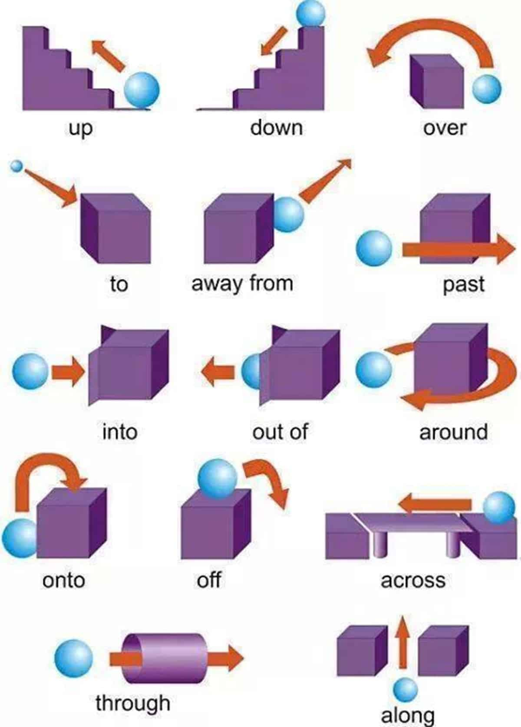

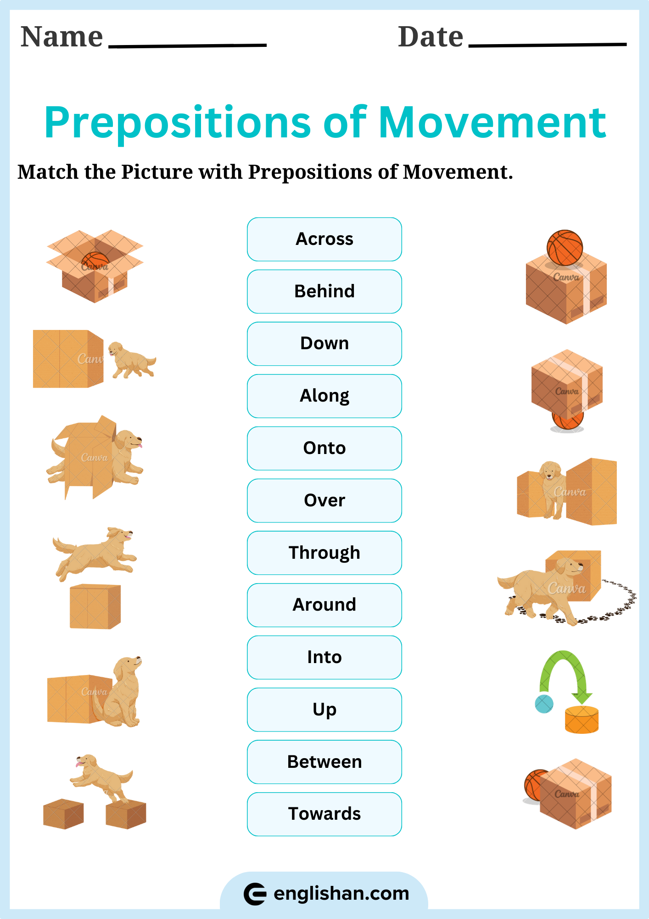

Rosary school / Irbid
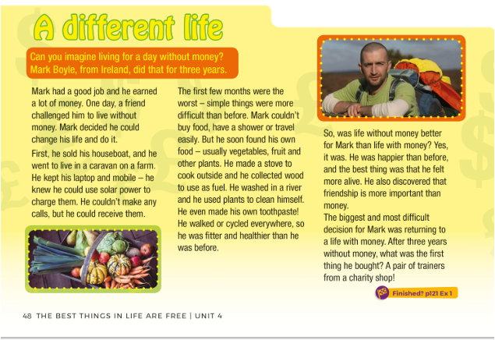
Studysheet grade 8(Reading and Vocabulary) unit 3

Main Points of the Passage
- Mark Boyle decided to live without money for three years after a friend challenged him.
- He sold his houseboat and moved to a caravan on a farm, using solar power and simple living.
- The first months were very hard because he couldn’t buy food, wash easily, or travel.
- He learned to live independently by growing his own food, collecting wood, making a stove, and even making his own toothpaste.
- He walked or cycled everywhere, becoming fitter and healthier.
- Mark found life without money happier and more meaningful, discovering that friendship is more important than money.
- After three years, the hardest part was returning to life with money, and the first thing he bought was a pair of trainers from a charity shop.

Phrasal Verbs from the Text
- Live without → manage without something
- Find out → discover or learn something new
- Return to → go back to something (a place or way of life)
- Made up (make up) → create or produce (he made up his own toothpaste)
- Pick up / collect (collect wood = pick up wood)

Word | Part of Speech | Meaning
Earned | Verb | Got money for work
Challenge | Noun or Verb | Something difficult you try to do
Live without | Verb phrase | Survive without using
Caravan | Noun | Small home on wheels
Solar power | Noun (compound noun) | Energy from the sun
Receive | Verb | Get something.
Difficult | Adjective | Hard
Travel | Verb or Noun | Go from place to place
Vegetables | Noun | Healthy plants you eat
Collect | Verb | Gather or pick up
Fuel | Noun | Something that gives energy (like wood)
Discover | Verb | Find out something new
Important | Adjective | Very necessary
Decision | Noun | Choice
Charity shop | Noun (compound noun) | Shop that sells donated items
Find out
- A word that means (Choice or judgment). __________________
- A phrasal verb that means (discover or learn something new)
_______________________
- Past Continuous Tense
- Adjectives
- Adverbs
- Synonyms
- Antonyms

