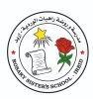
Rosary Sisters School
Vocabulary Study Sheet
Name: ___________ Date: __/11/2025

Save our World
- A meteorite: a fireball
- Extinction: death, when the last member of a species dies
- Humans: people
- Island: a piece of land surrounded by water
- Dodo: a large extinct bird
- Endangered: at risk of extinction, in danger of extinction in the future
- Pollution: the presence of materials that harm nature
- Climate change: changes in the weather
- Habitats: homes/ shelters
- Fur: soft hair covered certain animals’ bodies
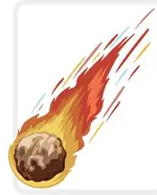

A meteorite

Animals in Australia
- Marsupials: animals that carry their babies in a pouch like a kangaroo.
- A Pouch : a pocket
- Venomous: poisonous
- Species: kind/ type
- Tasmanian tiger: an extinct marsupial tiger from Tasmania ( an island state of Australia)
- A carnivorous animal: meat-eating, feeding on other animals
- Unfortunately: sadly, unluckily
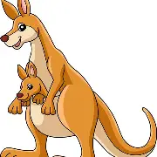
A pouch

Tr. Hazar Tashman

