
Rosary School/ Irbid
Name: Pronouns Date:
Grade 6

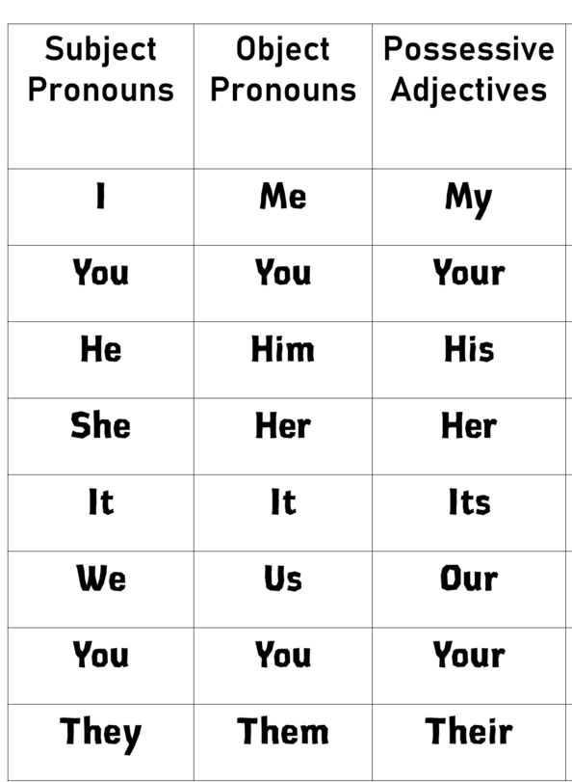
1. a word that modifies a noun to show ownership
2. before nouns
2. after ( with, by, for,to)

1. after verbs
2. after ( with, by, for,to)

1. at the beginning of the sentence.
2. before verbs
3. replace nouns that are the subject of the sentence.

