
Rosary Sisters School
Phonics – Pronunciation of ( ed )
Name: …………………. Date: …../12/2025
Grade 5 (a - b - c)
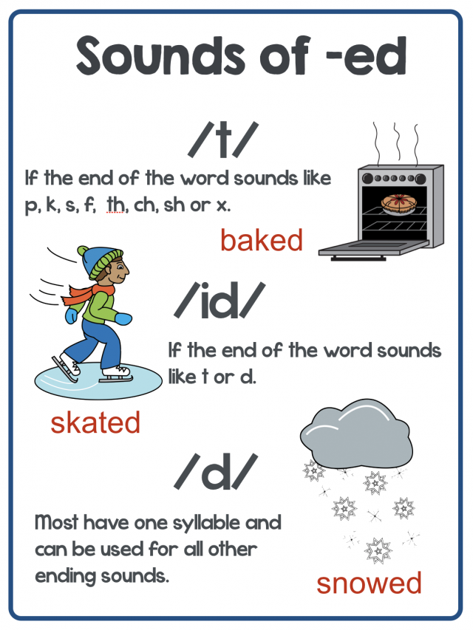

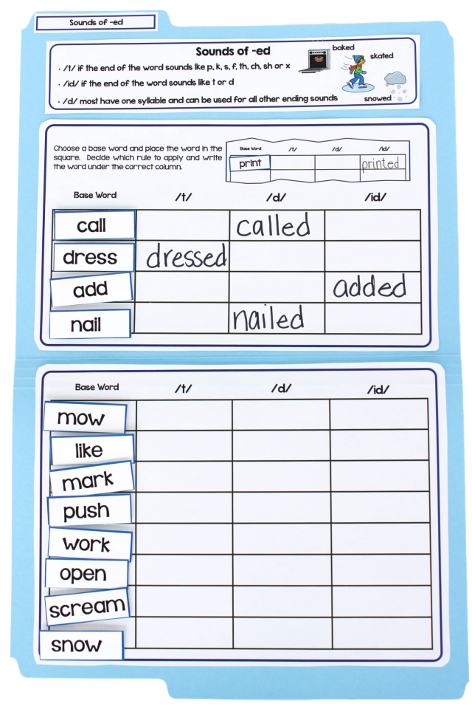

Tr. Hazar Tashman

