Rosary Sisters School
Comprehension Study Sheet
Name: __________ Grade 5 Date: …/12/2025

Unit 3
The Sport of Princes and Kings
- Falcon: a bird of prey, a carnivorous bird
- Falconry: is a sport of training and flying of falcons
- Prey: an animal that is caught and killed by another for food
- Mice: the plural of mouse
- Eyesight: the ability to see/ vision
- Hooked : curved
- Claws: nails
- UAE: United Arab Emirates
- Look after (phrasal verb): take care
- Captivity: arrested/taken / the antonym of freedom

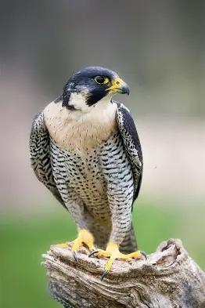
Tr. Hazar Tashman

